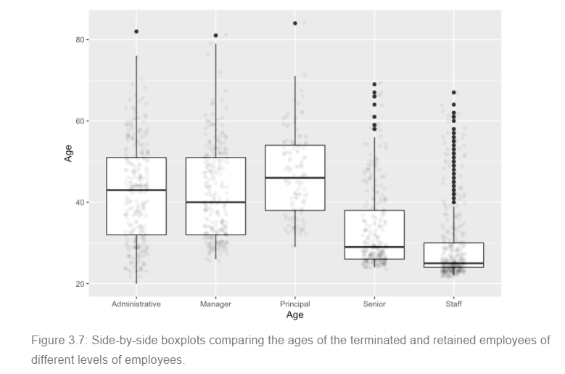

The stylized display of the box plot is most useful when comparing the distribution of a variable across two or more different groups, as in Figure 3.7. In that bar plot, you can see that employees at the “Principal” level tend to be somewhat older than other employees, that “Staff” tend to be the youngest, and that “Senior” employees are not so senior. You can also see that the age distribution for Staff is skewed toward higher ages, meaning that while most Staff are young – the median age is only 25, and three-quarters of staff are 30 or younger – there are several staff aged 40 and above, marked as individual dots to indicate that they fall quite far from the typical pattern: they are outliers. Notice also that a 50-year old is regarded as an outlier among the Staff, but is quite in the middle for Principals.

